Muhammad Sami Ullah
FA22-BCE-068

Task Report: Decision Tree Classification
Objective:
The objective of this lab was to understand and implement a Decision Tree classifier using Python's scikit-learn library. The goal was to build a model to predict whether tennis would be played based on weather conditions, evaluate its performance, and visualize the resulting decision-making logic.
Methodology:
The lab was conducted by following these steps:
- Loaded the "Play Tennis" dataset using the pandas library.
- Performed initial data analysis to understand its structure and contents.
- Preprocessed the data by encoding categorical string values (e.g., 'Sunny', 'Hot') into numerical values suitable for the machine learning algorithm.
- Split the dataset into a training set (70%) and a testing set (30%).
- Initialized and trained a DecisionTreeClassifier model using the 'entropy' criterion on the training data.
- Used the trained model to make predictions on the unseen test data.
- Evaluated the model's performance by calculating its accuracy, confusion matrix, and classification report.
- Generated and saved a visualization of the trained decision tree.

Results and Evaluation
This section presents the outputs generated during the model training and evaluation process as required by the lab manual.
1. Data Analysis and Preparation
The initial dataset consisted of 14 records and 6 columns. After encoding the categorical data, the features were successfully converted into a numerical format.
- Dataset Shape: (14, 6)
- Features Used for Prediction: 'Outlook', 'Temprature', 'Humidity', 'Wind'
- Target Variable: 'Play_Tennis'
2. Model Predictions
The following table compares the actual outcomes from the test set with the predictions made by the trained model.
Actual vs. Predicted Values:
Actual Predicted
9 1 1
11 1 0
0 0 0
12 1 1
5 0 1
3. Algorithm Evaluation
The performance of the classifier was evaluated using standard metrics. The model achieved an overall accuracy of 60%.
Confusion Matrix:
[[1 1]
[1 2]]
- True Negatives (TN): 1
- False Positives (FP): 1
- False Negatives (FN): 1
- True Positives (TP): 2
Classification Report:
precision recall f1-score support

0 0.50 0.50 0.50 2
1 0.67 0.67 0.67 3

accuracy 0.60 5
macro avg 0.58 0.58 0.58 5
weighted avg 0.60 0.60 0.60 5

4. Visualized Decision Tree

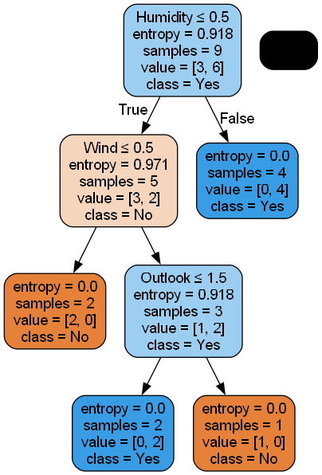
The final, labeled decision tree generated by the model is provided below. This visualization shows the decision rules the algorithm learned from the data. For example, the root node splits the data based on the 'Outlook' feature.
Conclusion:
This lab successfully demonstrated the process of building, training, and evaluating a Decision Tree classifier. The model was able to learn patterns from the weather data to predict whether tennis would be played, achieving an accuracy of 60% on the test set. The final visualization provides a clear and interpretable representation of the model's decision-making process, fulfilling the primary objectives of the lab.

